Iclass下載檔案:

1. 進入iclass把想要下載的檔案打開  
   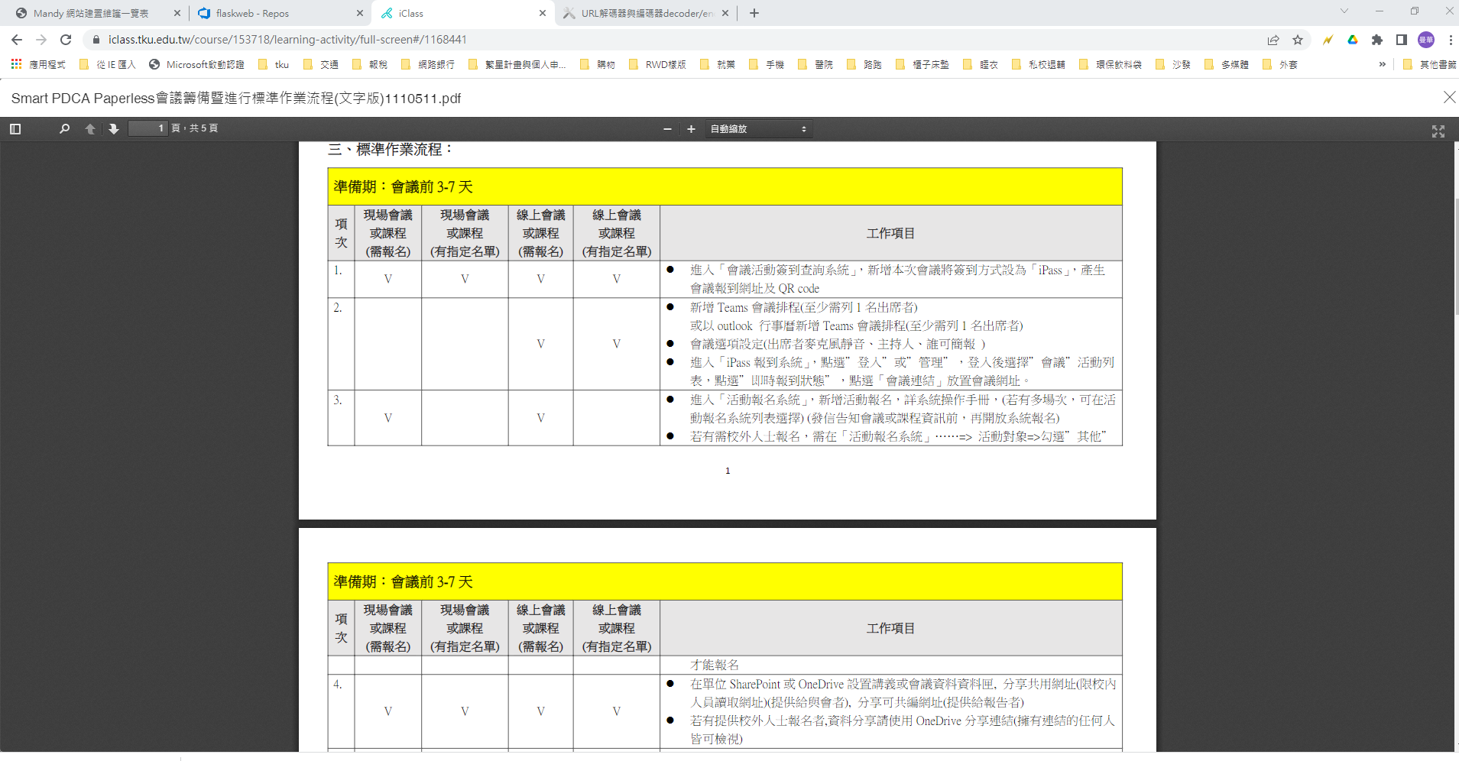
2. 按F12網頁開發者工具,出現如下畫面:  
   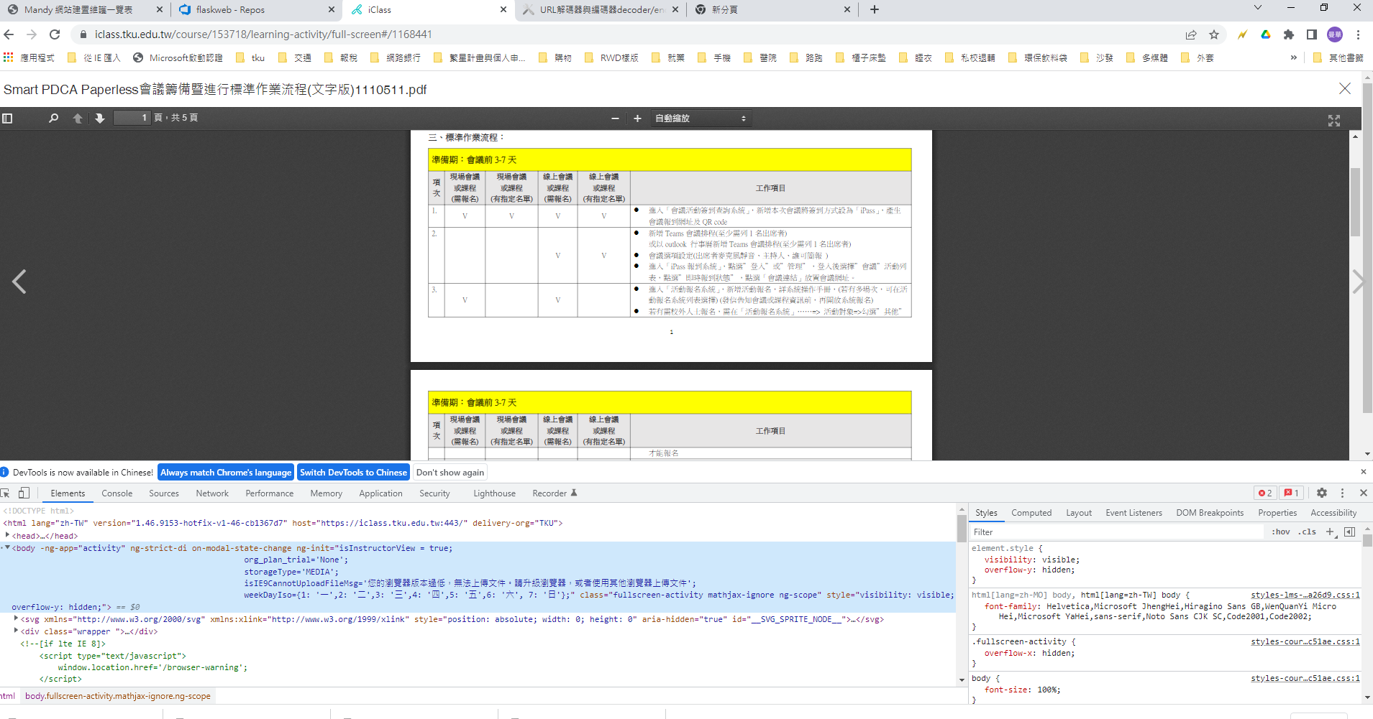
3. 對瀏覽器上的畫面按右鍵🡪檢查🡪會出現5頁  
   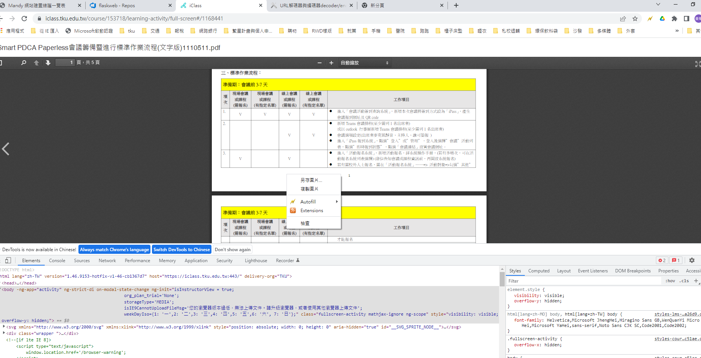  
   
4. 將捲軸往上捲,找到<iframe id=’pdf-viewer’的地方

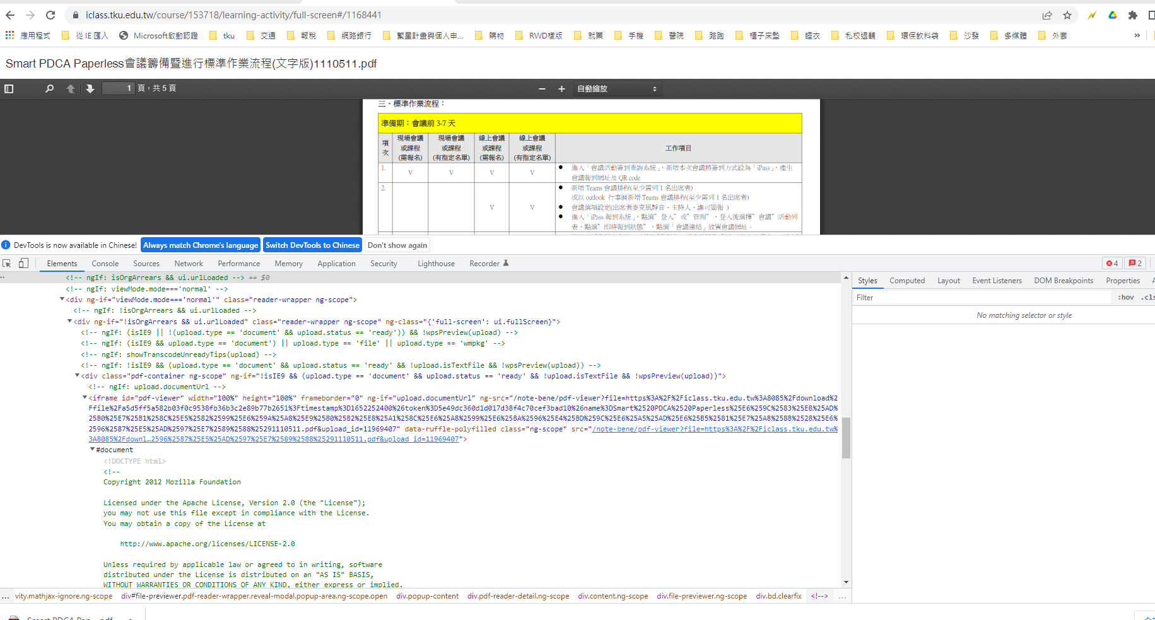

將整個iframe複製至記事本上編輯(點選🡪copy-🡪copy outerHTML)  
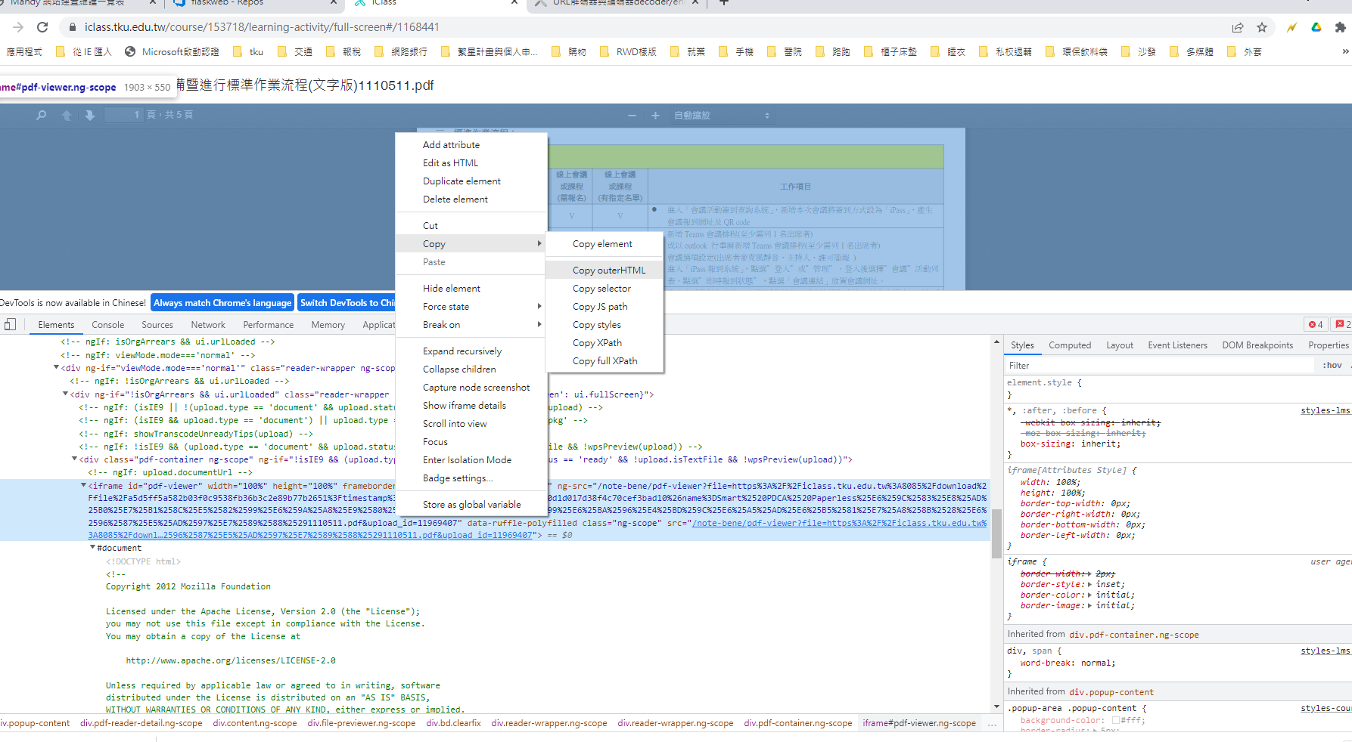

<iframe id="pdf-viewer" width="100%" height="100%" frameborder="0" ng-if="upload.documentUrl" ng-src="/note-bene/pdf-viewer?file=https%3A%2F%2Ficlass.tku.edu.tw%3A8085%2Fdownload%2Ffile%2Fa5d5ff5a582b03f0c9538fb36b3c2e89b77b2651%3Ftimestamp%3D1652252400%26token%3D5e49dc360d1d017d38f4c70cef3bad10%26name%3DSmart%2520PDCA%2520Paperless%25E6%259C%2583%25E8%25AD%25B0%25E7%25B1%258C%25E5%2582%2599%25E6%259A%25A8%25E9%2580%25B2%25E8%25A1%258C%25E6%25A8%2599%25E6%25BA%2596%25E4%25BD%259C%25E6%25A5%25AD%25E6%25B5%2581%25E7%25A8%258B%2528%25E6%2596%2587%25E5%25AD%2597%25E7%2589%2588%25291110511.pdf&amp;upload_id=11969407" data-ruffle-polyfilled="" class="ng-scope" src="/note-bene/pdf-viewer?file=https%3A%2F%2Ficlass.tku.edu.tw%3A8085%2Fdownload%2Ffile%2Fa5d5ff5a582b03f0c9538fb36b3c2e89b77b2651%3Ftimestamp%3D1652252400%26token%3D5e49dc360d1d017d38f4c70cef3bad10%26name%3DSmart%2520PDCA%2520Paperless%25E6%259C%2583%25E8%25AD%25B0%25E7%25B1%258C%25E5%2582%2599%25E6%259A%25A8%25E9%2580%25B2%25E8%25A1%258C%25E6%25A8%2599%25E6%25BA%2596%25E4%25BD%259C%25E6%25A5%25AD%25E6%25B5%2581%25E7%25A8%258B%2528%25E6%2596%2587%25E5%25AD%2597%25E7%2589%2588%25291110511.pdf&amp;upload_id=11969407">

</iframe>

==🡺編輯成(前後刪除,留file之後的https) https%3A %2F%2Ficlass.tku.edu.tw%3A8085%2Fdownload%2Ffile%2Fa5d5ff5a582b03f0c9538fb36b3c2e89b77b2651%3Ftimestamp%3D1652252400%26token%3D5e49dc360d1d017d38f4c70cef3bad10%26name%3DSmart%2520PDCA%2520Paperless%25E6%259C%2583%25E8%25AD%25B0%25E7%25B1%258C%25E5%2582%2599%25E6%259A%25A8%25E9%2580%25B2%25E8%25A1%258C%25E6%25A8%2599%25E6%25BA%2596%25E4%25BD%259C%25E6%25A5%25AD%25E6%25B5%2581%25E7%25A8%258B%2528%25E6%2596%2587%25E5%25AD%2597%25E7%2589%2588%25291110511.pdf

把編輯好的這串網址放到網路上decode(參考<https://youtils.cc/urldecoder/zh-Hants>)

<https://iclass.tku.edu.tw:8085/download/file/a5d5ff5a582b03f0c9538fb36b3c2e89b77b2651?timestamp=1652252400&token=5e49dc360d1d017d38f4c70cef3bad10&name=Smart%20PDCA%20Paperless%E6%9C%83%E8%AD%B0%E7%B1%8C%E5%82%99%E6%9A%A8%E9%80%B2%E8%A1%8C%E6%A8%99%E6%BA%96%E4%BD%9C%E6%A5%AD%E6%B5%81%E7%A8%8B%28%E6%96%87%E5%AD%97%E7%89%88%291110511.pdf>

將以上解碼後的連結用瀏覽器開啓(複製到瀏覽器),即可下載